**Final Report On**

**Android Based Expense Management App Submitted for the requirement of Project course**

**BACHELOR OF ENGINEERING**

**COMPUTER SCIENCE & ENGINEERING**

**DEPARTMENT OF COMPUTER SCIENCE & ENGINEERING CHANDIGARH UNIVERSITY, GHARUAN**

**Supervisor Signature Co-Supervisor**

**Er. Nisha Rani Er. Gaganjot Kaur**

**SUBMITTED BY**

|  |  |  |  |
| --- | --- | --- | --- |
| S NO. | NAME | SECTION | CONTACT |
| 1 | ADITYA RAJ | 709-B | 7004292500 |
| 2 | ABHISHEK VERMA | 709-B | 8091768971 |
| 3 | KARTIK | 709-A | 9816927088 |
| 4 | VAISHNAVI MAMIDEPPELLI | 709-B | 7671044022 |

**BONAFIDE CERTIFICATE**

Certified that this project report “ **Android Based Expense Management App** ” is the bonafide work of “ ADITYA RAJ ” who carried out the project work under my/our supervision.

**ACKNOWLEDGEMENT**

I have taken efforts in this project. However, it would not have been possible without the kind support and help of many individuals and organizations. I would like to extend my sincere thanks to all of them.

I am highly indebted to “**CHANDIGARH UNIVERSITY”** for their guidance and constant supervision as well as for providing necessary information regarding the project & also for their support in completing the project.

I would like to express my gratitude towards my project suprvisor **Er. Nisha Rani** & member of Project team for their kind co-operation and encouragement which help me in completion of this project.

I would like to express my special gratitude and thanks to industry persons for giving me such attention and time.

My thanks and appreciations also go to my colleague in developing the project and people who have willingly helped me out with their abilities.

**TABLE OF CONTENTS**

1. **ABSTRACT. (PAGE NO. 6)**
2. **INTRODUCTION. (PAGE NO. 7 - 13)**
   * SOFTWARE USED. (PAGE NO. 8)
   * HARDWARE USED. (PAGE NO. 9)
   * REQUIRED FUNDS. (PAGE NO. 9)
   * LIFE CYCLE. (PAGE NO. 10)
   * RISK AND UNCERTAINITY. (PAGE NO. 10)
   * DIRECTION. (PAGE NO. 11)
   * UNIQUENESS. (PAGE NO. 12)
   * FLEXIBLITY. (PAGE NO. 12)
   * SUB-CONTRACTING. (PAGE NO. 13)
3. **LITERATURE SURVEY. (PAGE NO. 14 - 16)**
4. **DESIGN FLOW/PROCESS. (PAGE NO. 17 - 19)**
   * ER DIAGRAM. (PAGE NO. 17)
   * LEVEL 0 DFD. (PAGE NO. 17)
   * LEVEL 2 DFD. (PAGE NO. 18)
   * SEQUENCE DIAGRAM. (PAGE NO. 18)
   * CLASS DIAGRAM. (PAGE NO. 19)
5. **RESULT ANALYSIS AND VALIDATION. (PAGE NO. 20 -30)**
6. **CODE AND SOURCE FILE. (PAGE NO. 31 - 32)**
7. **SCOPE AND FUTURE WORK. (PAGE NO. 33)**
8. **REFERENCES. (PAGE NO. 34)**

**LIST OF FIGURES**

1. **ER DIAGRAM.**
2. **LEVEL 0 DFD.**
3. **LEVEL 1 DFD.**
4. **SEQUENCE DIAGRAM.**
5. **CLASS DIAGRAM.**
6. **PRESENTATION PAGE 1 - 11.**
7. **LOGIN PAGE.**
8. **REGISTRATION PAGE.**
9. **PASSWORD RESET PAGE.**
10. **MENU PAGE.**
11. **ABOUT PAGE.**
12. **LOGOUT PAGE.**
13. **TOOLS PAGE.**
14. **INTEREST CALCULATOR.**
15. **EMI CALCULATOR.**
16. **INCOME AND EXPENSE SEARCH PAGE.**
17. **DASHBOARD PAGE.**
18. **EXPENSE HISTORY PAGE.**
19. **INCOME HOSTORY PAGE.**

**ABSTRACT**

Keep in mind that many people face problems with expense management. So, we took the initiative to build a app for customers which helps in managing the expenses and getting it used at right time, and avoiding unnecessary expenses. Users can set budget on the app. They can easily monitor it through visualized graph. They can search when was expenses over the budget, it will also tell how much time is needed to neutralize the expenses. This app shows detailed information about expenses on daily basis. This application provides login to the user. They can see their previous and current expenses. Using our service, customers can more efficiently handle its expenses. Not only can this program help users handle their expenditures, but it will also help marketing executives organize campaigns according to user needs. With advanced features such as auto scan for receipts, it stands out as a quick but effective solution for controlling and maximizing the expenses of the company. This makes the analysis and cost flow smoother, with the recording of expenses offline without internet will not be a burden.

**Chapter 1: Introduction**

As we know the mobile app is rapidly growing all over the globe and people are preferring to use the app that can manage daily task on regular basis on the fingertip, as the app are fast, reliable, and cheap.  
Project **“Android-Based Expense Managing App”** has developed to override all those problems prevailing in the practice of the manual system. This project will help to reduce the hardship faced by the existing system. This is going to be a user-friendly app and anyone can use it without facing any problems. Its design is simple, unique, and user-friendly. When anyone enters the wrong data then error message pop up on the display asking the user to enter the correct details again. The purpose behind is this is to reduce errors in the beginning. This app is reliable, fast, and secure.

* In today’s era, you have the usual array of rent and utilities to pay.
* Can’t handle our cash flow.
* Find an easier way to get rid of this problem.
* This project is an attempt to manage our daily expenses in a more efficient and manageable way.
* **Our application helps in,**
* Keep the control on the expenses.
* Free the user with as much as possible the burden of manual calculation.
* Keep the track of the expenditure.

**SOFTWARE USED :**

1. **JAVA:**

Java is a high-level, class-based, object-oriented programming language that is designed to have as few implementation dependencies as possible. Java has an extensive set of libraries. It is easy to take advantage of these libraries. Android SDK has many standard Java libraries included. Android is made to run on different platforms i.e. hardware platforms. Thus architectural neutrality is desired and necessary. Android code is written once and to execute need to compile and optimize native code for better performance on various devices. Java has platform independent feature, so it is used for android development.

1. **XML:**

XML stands for Extensible Markup Language. XML is a markup language much like HTML used to describe data. It is derived from Standard Generalized Markup Language(SMGL). Basically, the XML tags are not predefined in XML. We need to implement and define the tags in XML. XML tags define the data and used to store and organize data. It’s easily scalable and simple to develop. In Android, the XML is used to implement UI-related data, and it’s a lightweight markup language that doesn’t make layout heavy. XML only contains tags, while implementing they need to be just invoked.

1. **Android Studio:**

Android Studio is the official integrated development environment ([IDE](https://www.techtarget.com/searchsoftwarequality/definition/integrated-development-environment)) for Android application development. It is based on the [IntelliJ IDEA](https://www.theserverside.com/definition/IntellJ-IDEA), a [Java](https://www.theserverside.com/definition/Java) integrated development environment for software, and incorporates its code editing and developer tools.

To support application development within the Android operating system, Android Studio uses a Gradle-based build system, emulator, code templates, and [Github](https://www.techtarget.com/searchitoperations/definition/GitHub) integration. Every project in Android Studio has one or more modalities with source code and resource files. These modalities include Android app modules, Library modules, and Google App Engine modules.

1. **Firebase:**

Owned by Google, Firebase is a complete package of products that allows to build web and mobile apps, improve the app quality, and help your clients grow their business. Firebase manages all data real-time in the database. So, the exchange of data to and for from the database is easy and quick. Hence, if you are looking to develop mobile apps such as live streaming, chat messaging, etc., you can use Firebase. Firebase allow syncing the real-time data across all the devices- Android, iOS, and the web without refreshing the screen. Firebase offers integration to Google Ads, AdMob, DoubleClick, Play Store, Data Studio, BigQuery, and Slack, to make your app development with efficient and accurate management and maintenance

**HARDWARE TOOLS USED :**

* OPERATING SYSTEM (LINUX, MACOS, WINDOWS).
* RAM 8 GB OR 8+ GB.
* 6 OR HIGHER CORE PROCESSOR.
* MONITOR.
* KEYBOARD.
* MOUSE.
* MEMORY OF ABOUT 10 GB.
* INTERNET

**SINGLE ENTITY :**

Our project is divided into 4 phases.

**a) Phase 1 (Project scope and task planning):**

• Recognize the need (beneficiary/client) or relevant contemporary issues to define the scope of the project work.

• Identify the problem either by engagement with the beneficiary/client or by correlating the identified problem against the contemporary issue.  
• Divide the work, identify the tasks and create a Gantt chart/ timeline to plan the project.

**b) Phase 2: Background study/ Literature Review**:  
• Identify relevant topics for background study/ literature review.  
• Review previous solutions or related materials and identify the extent and relevance of materials reviewed to project at hand

• Summaries, how reviewed literature helped in defining problem statement.

• Define problem (under the scope of previous solutions) • Set goals and define objectives

**c) Phase 3: Selection of Design flow/ process/ methodology:**

• Identify the Constraints of the project based on:  
• Regulations & Design Constraints considered in design  
• Analyze and finalize the Features/ characteristics of the solution subject to constraints.  
• Generate multiple design alternates/ solutions  
• Selection of Best Design/ solution and create implementation plan (plan to validate the solution/ proof of concept)

**d) Phase 4: Detailed System Design/Technical Details**:  
• Implement the design/solution using Modern tools in analysis, design drawings /schematics/solid models, report preparation, project management,

and communication. Perform Testing/characterization/interpretation/data validation to support the solution Documentation in the form of project report.

**3. Required Funds:**

System cost can be defined in earlier stages of system development. Though this is a general system, a cost plane is identified. The cost plan is divided in two phases:

* Cost of development
* Cost of using the system

**• Cost of Development**: In cost of development, programmers, analyst other people’s salary who are related in development. Again, costs of computer, hardware, testing, training etc. are involved. But system development cost is just onetime cost, which will not recur after the project has been developed.

**• Cost of using the system**: Cost of using the system is pre-defined and, in some times, it’s depending on user. Cost of using a system can be divided in two ways:

**• Fixed cost**

**• Variable cost Fixed cost:**

• Software purchase cost & license cost is zero.

• Salaries of system operation are fixed, but it depends on client software also.

**Variable cost:**

• Cost of computers used  
• Suppliers e.g., printer, paper, etc.

**4. Life Cycle:**

SDLC Cycle represents the process of developing software. SDLC framework includes the following steps:.[7]

**a) Stage 1: Planning and requirement analysis**

Requirement Analysis is the most important and necessary stage in SDLC. Recognize the need (beneficiary/client) or relevant contemporary issues to define the scope of the project work. Identify the problem either by engagement with the beneficiary/client or by correlating the identified problem against the contemporary issue. Divide the work, identify the tasks and create a Gantt chart/ timeline to plan the project

**b) Stage 2: Defining Requirements**

Once the requirement analysis is done, the next stage is to certainly represent and document the software requirements and get them accepted from the project stakeholders. This is accomplished through "SRS"- Software Requirement Specification document which contains all the product requirements to be constructed and developed during the project life cycle.

**c) Stage 3: Designing the Software**

The next phase is about to bring down all the knowledge of requirements, analysis, and design of the software project. This phase is the product of the last two, like inputs from the customer and requirement gathering.

**d) Stage 4: Developing the project**

In this phase of SDLC, the actual development begins, and the programming is built. The implementation of design begins concerning writing code. Developers have to follow the coding guidelines described by their management and programming tools like compilers, interpreters, debuggers, etc. are used to develop and implement the code.

**e) Stage 5: Testing**

After the code is generated, it is tested against the requirements to make sure that the products are solving the needs addressed and gathered during the requirements stage. During this stage, unit testing, integration testing, system testing, acceptance testing is done.

**f) Stage 6: Deployment**

Once the software is certified, and no bugs or errors are stated, then it is deployed. Then based on the assessment, the software may be released as it is or with suggested enhancement in the object segment. After the software is deployed, then its maintenance begins.

**g) Stage 7: Maintenance**

Once when the client starts using the developed systems, then the real issues come up and requirements to be solved from time to time. This procedure where the care is taken for the developed product is known as maintenance.

**5. Risk and Uncertainty**:  
• The database may get crashed at any certain time due to virus or operating

system failure. Therefore, it is required to take the database backup.  
• The system requires to work on real time working and saving of data like

laps. So it must be kept under time to time maintenance.  
• The development of the system will be constrained by the availability of

required software such as web servers, database and development tools.

**6. Directions:**

1. The first step was to understand the project scope and problem statement.
2. The next step was to create a timeline and divide the work with team members.
3. The next step was to set the goals and objective of our project.
4. Further we did ample literature reviews to understand the project.
5. Further we designed the concerned project reports and weekly progress reports. f) We then identified the constraints, features and characteristics of the project.
6. The next step was to identify the optimal design process and implementing the same.
7. The final step was to test the project with the help of our teachers.

**7. Uniqueness:**

The uniqueness of our project is its modern approach to now days expense management you need to store or record your budget which it will be very helpful in it works on real time it is visually attractive it can record your expense and you can even see the visualization.

**Flexibility:**

Our project saw many changes throughout its life span. These changes helped us to make our project more dynamic and flexible:

1. Allowed users to enter the income and expenses.
2. Allowed users to change and delete account.
3. Added a visualization of expenses.
4. Added the feature of user to renew all the data.

**8. Sub-Contracting:**

Sub-contracting is a subset of every project and without which no project can be completed unless it is a proprietary firm or tiny in nature. The more complexity of a project the more will be the extent of contracting. Every

project needs the help of an outsider consultant, engineer, or expert in that field. We are thankful to:

**a) Er. Nisha Rani,** Assistant Professor, Department of Computer Science, Chandigarh University, Mohali

**b) Er. Gaganjot Kaur**, Assistant Professor, Department of Computer Science. Chandigarh University, Mohali for their guidance, continuous encouragement, patience and supervision throughout the course of present work. They helped us in exploring this topic and providing me with ideas to work on this topic.

**Life Span:** The life span describes the time taken for the project to be completed and all the planning[9]

**Phase 1**: Project scope and task planning: (7-8 th March, 2022 - 15 th March, 2022)  
**Phase 2**: Background study/ Literature Review: (17th March, 2022 - 4 th April, 2022)

**Phase 3**: Selection of Design flow/ process/ methodology: (5th April, 2022 - 24th April, 2022)  
**Phase 4**: Detailed System Design/Technical Details: (28th April, 2022 - 11th May, 2022)

**Phase 6**: Organisation of report : ( 12th May, 2022 - 18 st May, 2022)

**Phase 7**: Monitoring and Evaluation: (19th May, 2022 - 1 st June, 2022)

**Chapter 2: Literature survey**

**S. Surekha, G. Swetha, Sri Ram Gowd Vuppala, Arya Vishnu Thotakura, Tejasvi Dasari, R. Imayavaramban & T. C. Jermin Jeaunita Android Application for Business Expense Management.**  
https://link.springer.com/chapter/10.1007/978-3-030-90119-6_21

In this study, we created a smartphone app that tracks users' 'personal costs.' A cloud-based expense management tool keeps track of and reports on all client expenditures. It makes it easy to keep track of any expenditure for a larger number of members of the workforce when old methods are often ineffective and time consuming. This tool will not only assist users in managing their finances, but it will also assist marketing executives in organising campaigns based on user needs. [1]

**Shahed Anzarus Sabab; Sadman Saumik Islam; Md. Jewel Rana; Monir Hossain eExpense: A Smart Approach to Track Everyday Expense.**

<https://ieeexplore.ieee.org/abstract/document/8628070>

We mentioned in this paper that tracking recurring costs is an important part of budgeting. People frequently keep track of their costs on paper or on their cell phone or computer. To use this data as a traceable record, this cost storage technique necessitates further computations and processing. We propose an automated system named eExpense to store and calculate this data in this research. eExpnese is a smartphone application that runs on Android. This app can assist you in saving money. [2]

**Android Application for Business Expense Management.**

<https://link.springer.com/chapter/10.1007/978-3-030-90119-6_21>

In this research, it was discussed that mobile devices ranked #1 in terms of consumer accessibility and convenience. In the sector, there are numerous options for controlling personal and corporate spending. We're working on a smartphone app that tracks a user's personal and private contributions to government spending in this project. A cloud-based cost management tool keeps track of and reports on all company expenses. This makes it easier to track costs for a company's growing number of employees, where old methods might be ineffective and time-consuming. Our software is tailored to the demands of enterprises and organisations that require employee payment and acceptance by business participants with access and approval rights. Our services can help customers better manage their expenses. [3]

**Bogdan IONESCU1, Iuliana IONESCU, Laura TUDORAN and Andreea BENDOVSCHI.**

https://www.researchgate.net/profile/Laura-Brad/publication/ 260083245_QUANTIFYING_THE_ROMANIAN_BANKS'_PERFORMANCE_AND_THE_IMPACT_OF _AUDIT_INSPECTIONS_UPON_THEM_WHEN_IFRS_REPORTING_STANDARDS_IS_USED/links/ 0a85e534000ec1caed000000/QUANTIFYING-THE-ROMANIAN-BANKS-PERFORMANCE-AND-THE- IMPACT-OF-AUDIT-INSPECTIONS-UPON-THEM-WHEN-IFRS-REPORTING-STANDARDS-IS- USED.pdf#page=107

The research period for dematerialization of accounting records and the transfer of some accounting procedures to the cloud electronic platform has passed, as there are already numerous companies in Romania creating and providing cloud computing-based accounting software. The purpose of this essay is to see if the cost reductions incurred by using cloud-based applications are significant enough to be a deciding factor when selecting an online accounting solution. [4]

**Chapter 3: Design flow/Process**

* **ER DIAGRAM**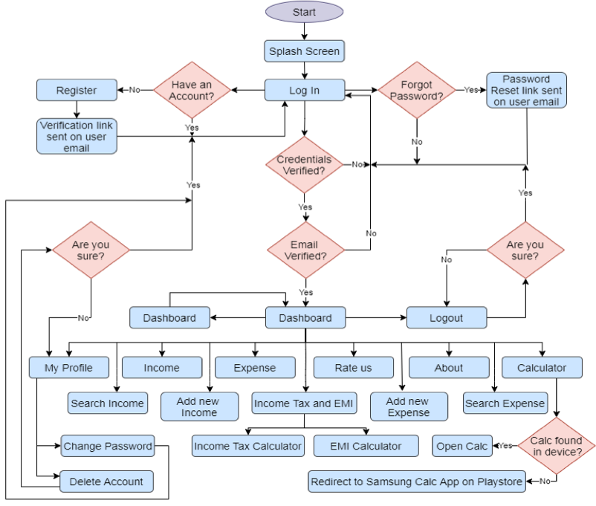

Fig 1.1

* **DATA FLOW DIAGRAM**

1. LEVEL 0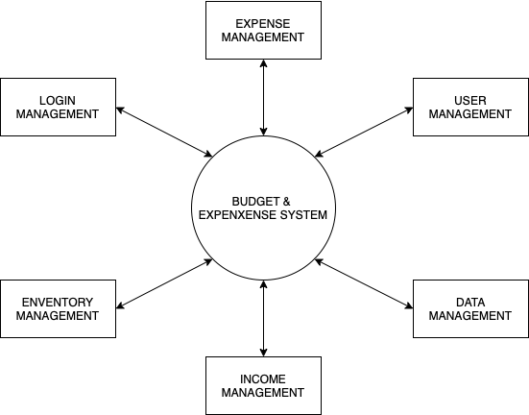

Fig 1.2

1. LEVEL 1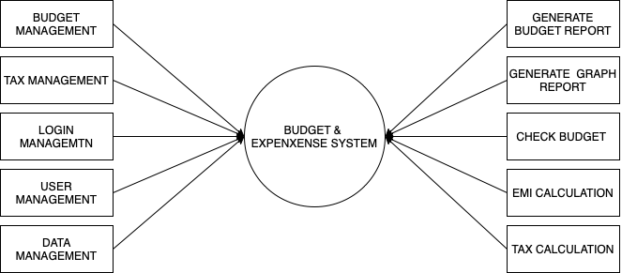

Fig 1.3

* **SEQUENCE DIAGRAM**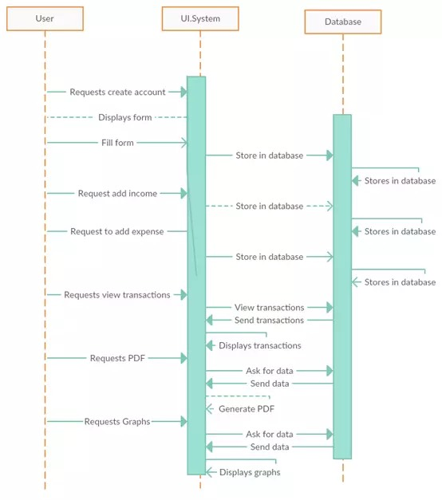

Fig 1.4

* **CLASS DIAGRAM**

A Class Diagram in Software engineering is a static structure that gives an overview of a software system by displaying classes, attributes, operations, and their relationships between each other. This Diagram includes the class name, attributes, and operation in separate designated compartments.

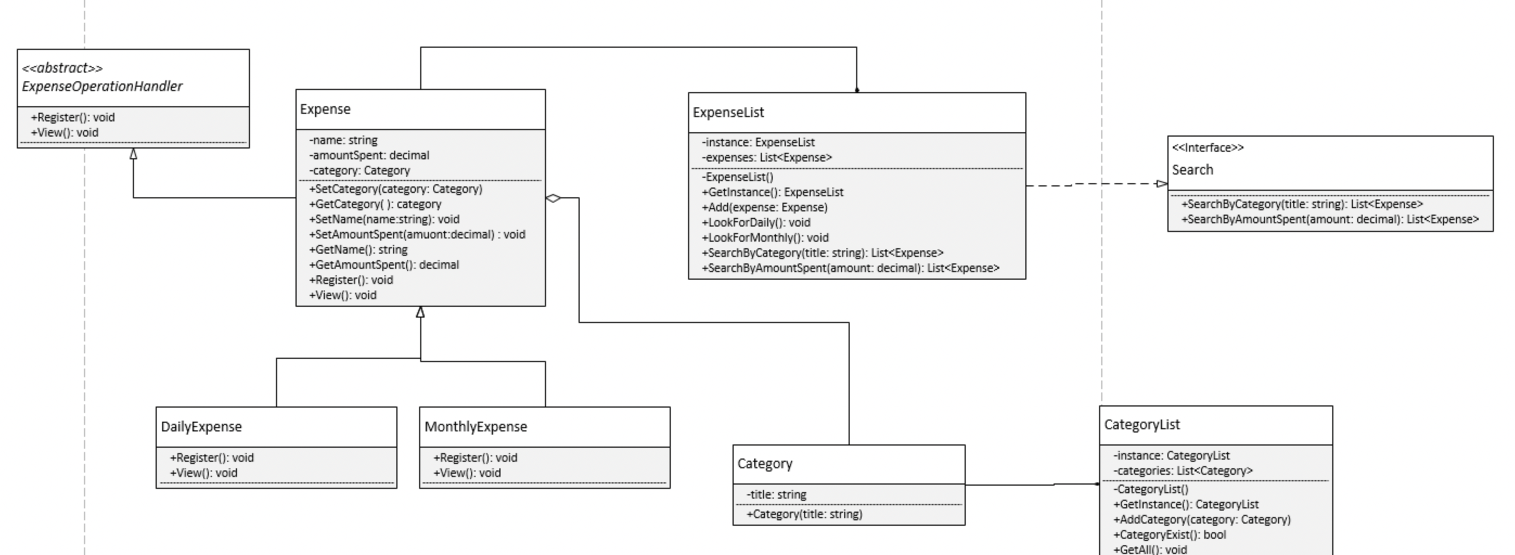

Fig 1.5

**Chapter 4 Results analysis and validation**

Managing this (“Android Based Expense Management App”) whole system is seem a little bit tricky and compact but it is part of the User Experience. Managing daily expenses is not an easy task because it’s difficult to keep records of every expenses on daily bases and to keep track of budget on the go. The App user has to note the expenses to keep track on budget and this task going to be carried out through app. This project work will help in money management and will prevent uneccessay expenses.

ExpensO has been tested with 30 volunteers who used and were instructed to use the application for managing their expenses. They were provided with the apk file and the instructions about the usage. All volunteers used the application for their expense division and management. A feedback was taken from each volunteer individually. The overall satisfaction level was found to be 95% and a number of suggestions to make it more user friendly was received. Volunteers suggested that if there is some expense which is to be divided only among a few in the group then provision for doing so should be available. For this, a provision was made to include only a few among the members for a particular bill. It was also noted that a person who paid multiple bills had to calculate the total and then enter it in the application, responding to this a calculator was added in the billing module.

An expense report consists of several moving parts. User need to submit receipts and create expenses.  
All of these processes make an intuitive dashboard a must-have software feature. A dashboard gives you insight into your expense reporting processes, breaking down the various components into easily digestible information. Most software programs have a dashboard. The trick can be finding one that’s easy to use and understand. A valuable dashboard shows you:

* The status of each employee’s expense report
* Missing or denied expense reports
* Policy violations
* Spending limits   
  You should also be able to take action directly from the dashboard and easily:
* Approve or deny expense reports
* Add or edit expenses
* Identify spending trends.
* **Mobile app :**

User may need to submit expenses while traveling or working remotely. That’s why it’s important to have an expense management solution with mobile accessibility.  
Most software providers offer some form of mobile functionality, but an app is usually the most convenient. With a mobile app, users can create, submit, and manage their expenses right from their phones. Your managers can also securely review and approve expense reports from any location.  
Look for a solution with a user-friendly app that can be easily navigated. A cloud-based app that connects to database and payroll system in real-time is also helpful. This way, you’ll be able to monitor spending and provide assistance even when your employees are away.  
Expense tracker  
Consider expense management systems with built-in mobile trackers. user can enter their budget, and the software will automatically calculate their mileage and resulting reimbursement amount. This saves time and also helps you ensure that their mileage is accurate.

* **Automated workflows:**

An online expense management app gives employers the freedom to customize their policies and approval workflows as desired. With a well-defined approval workflow, expense reports are approved and processed like clockwork. Saving your time and money.

* **Continuous compliance:**

Expense management software can help user stay on the right side of compliance with expense and getting out of budget. User can easily place expenses into categories, like office, travel and mileage, and tag them appropriately.

**Built - in Privacy Protection :**

An expense management app shouldn’t just think about its users, but also its data. That’s why it’s important to invest in a expense management that is built to protect privacy. Some privacy- related features to look for include:

* Data encryption– The data is encrypted both at rest and during transmission.
* Data purging– Surveillance data should be automatically purged at regular intervals in accordance with industry best practices
* Anti-profiling– Expense Management systems should be built to prevent profiling by race, age, gender or national origin.
* Firebase provide all these feature in the backend so that the data is safe.

**Cost :**

What is the cost of developing the expense management from scratch? And the answer is that it depends on the project requirements. As we describe it above, there are many variables that comprise the total price but we are making it totally free .

To offer the client the best solution to meet challenges, our company enters such projects with the Investigation Stage aimed at the following:

Income objectives analysis  
Data analysis and identification of the scope of work  
Definition of high-level architecture and appropriate tools and technologies selection Risks identification  
Building proof of concept  
Definition of the expected results as well as costs and resources estimation.

**Risk :**

Expense management system also carries other risks, such as errors, which could, for example, lead to loss of data. And as with any android system, we should be concerned about whether the algorithms, formulas and data sets are free from bias, and have clean, complete and representative training data.

Importantly, user expense technologies in android also goes some way to normalizing the severity of data loss. It’s possible the knowledge they are being tracked in this way could impact some users wellbeing.

**Benefit :**

Expense management system is a application that can benefit users including increasing safety and security and for making best budgets. Here are some pros of this application:

* Fast and Simple Process.
* Less Errors and Delays.
* Improved Efficiency in Operations. Expense Policy Enforcement.
* Improved Visibility.
* Enhanced Fraud Prevention

**Screenshots :**

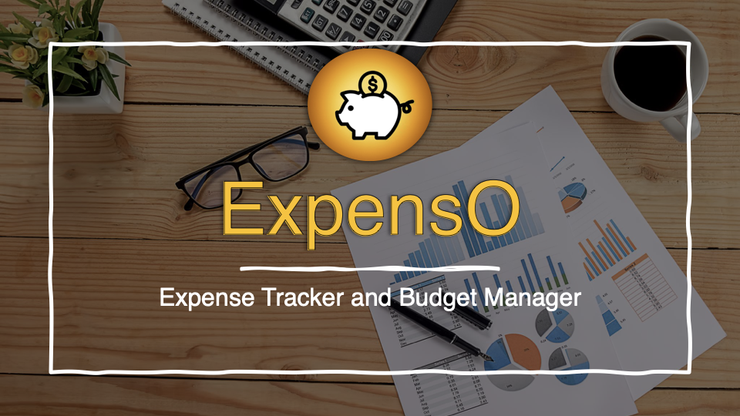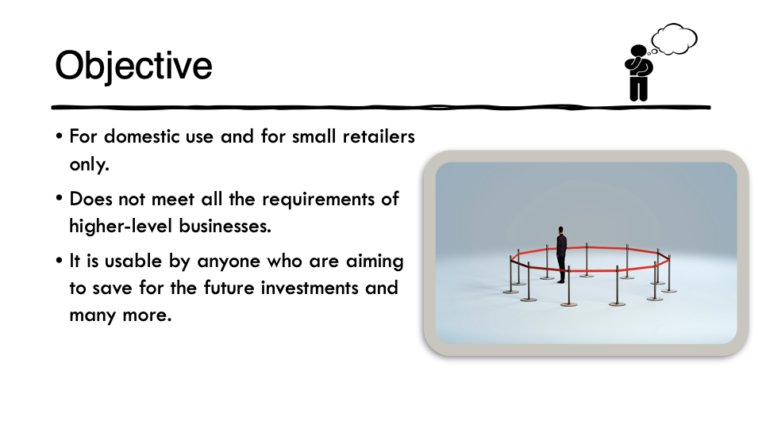

Fig 2.1

Fig 2.2

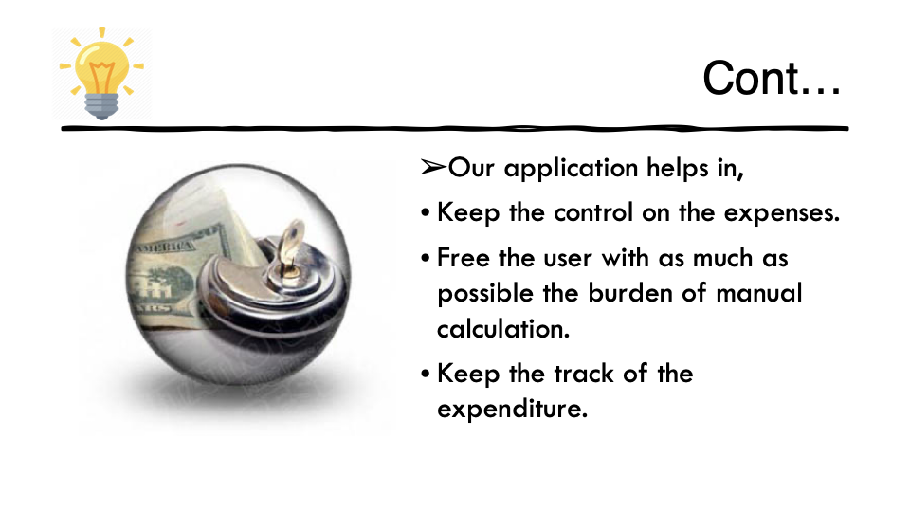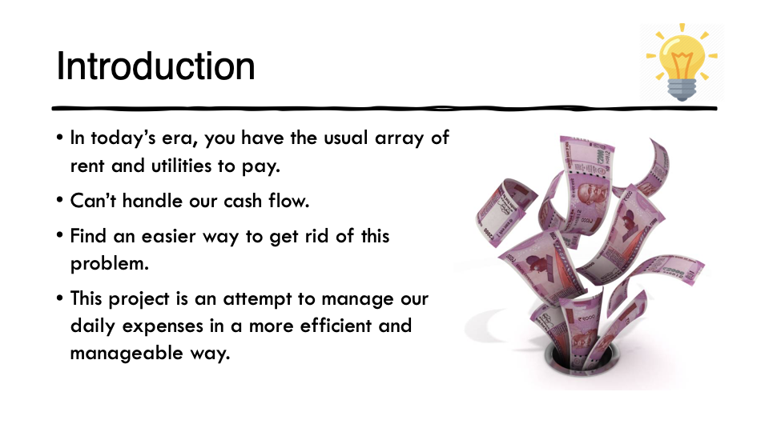

Fig 2.3

Fig 2.4

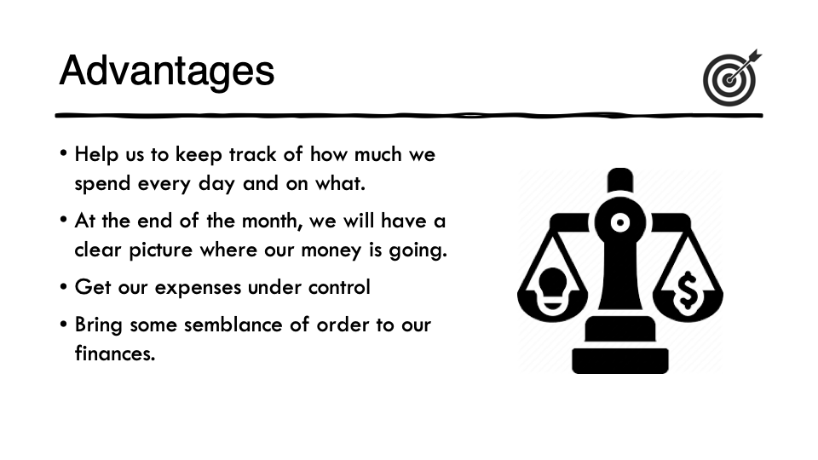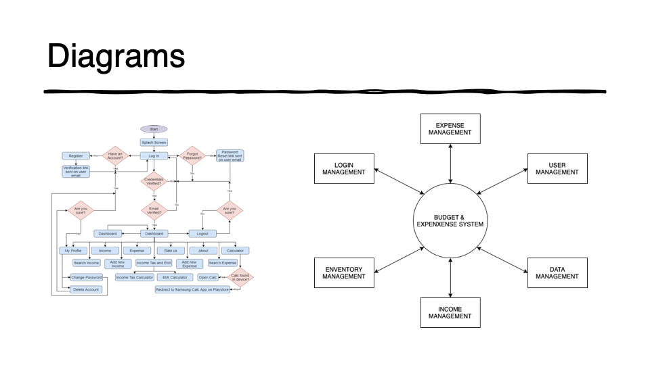

Fig 2.5

Fig 2.6

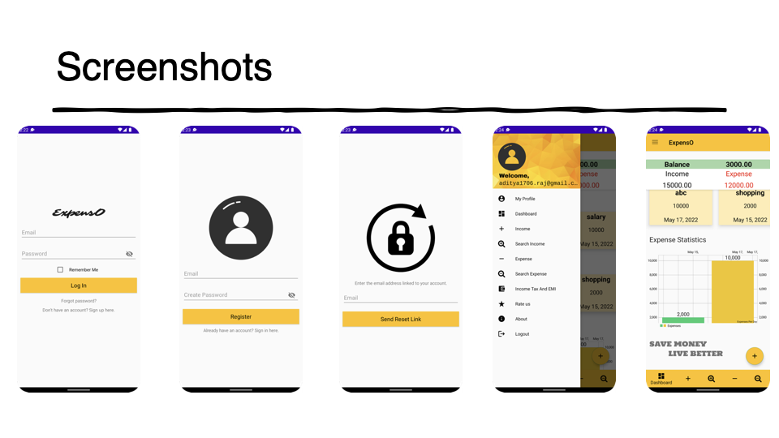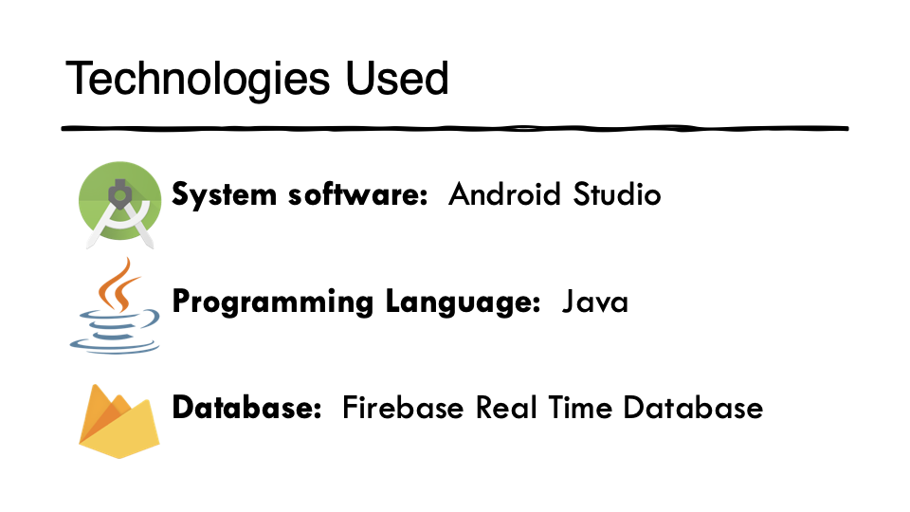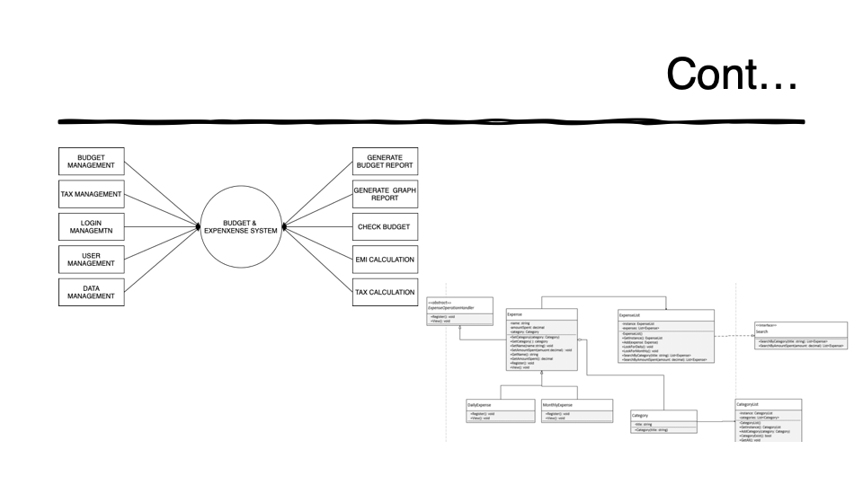

Fig 2.9

Fig 2.7

Fig 2.8

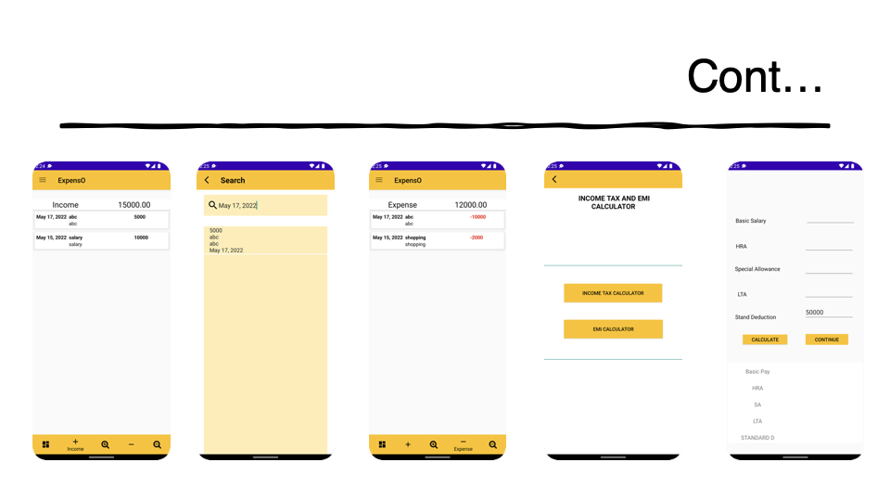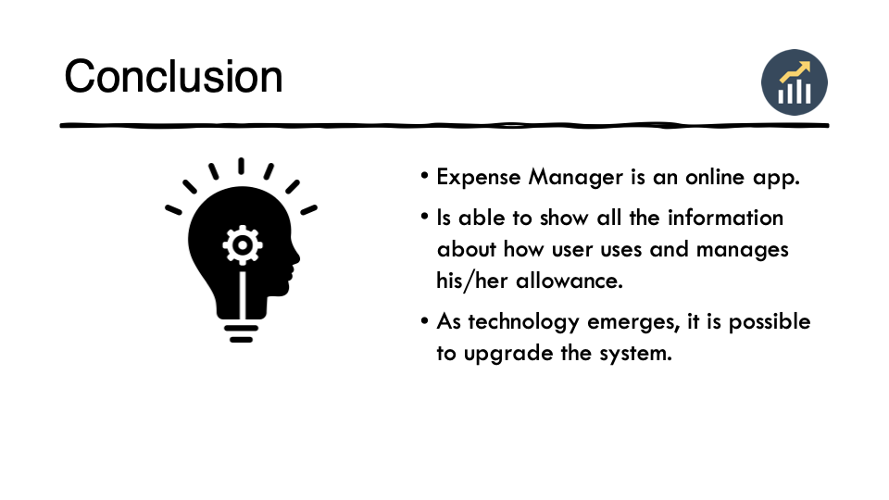

Fig 2.11

Fig 2.10

**Screenshots of app:**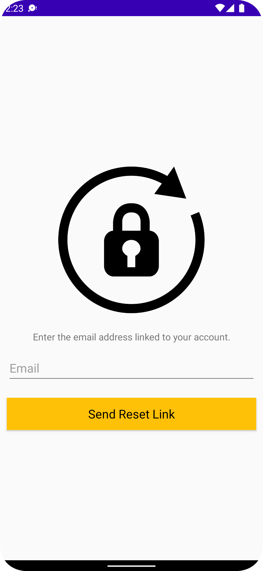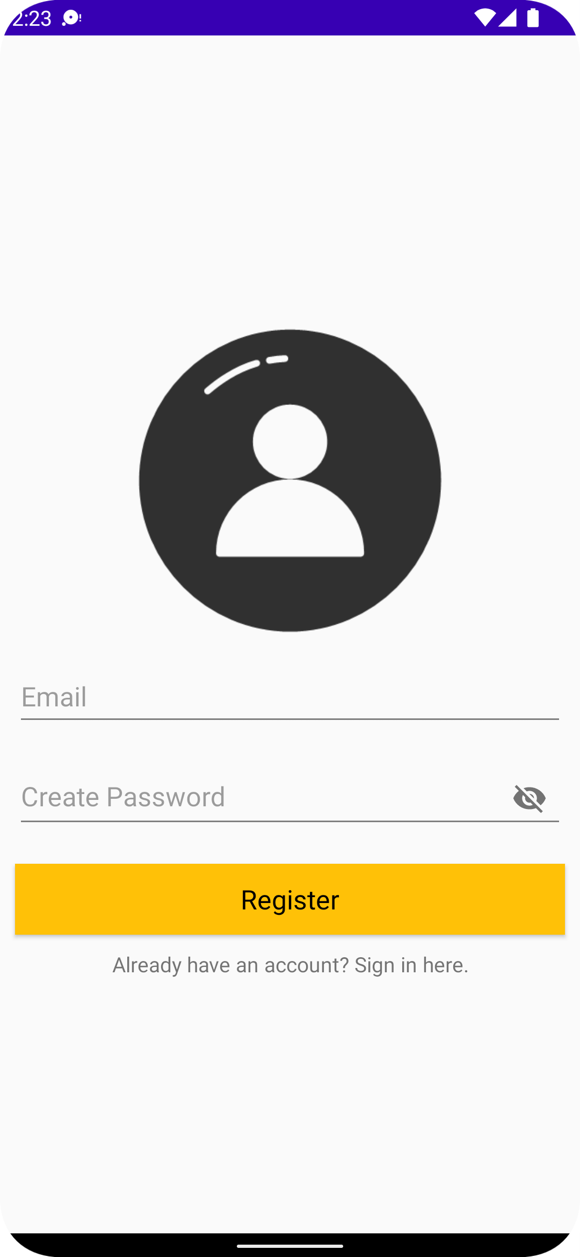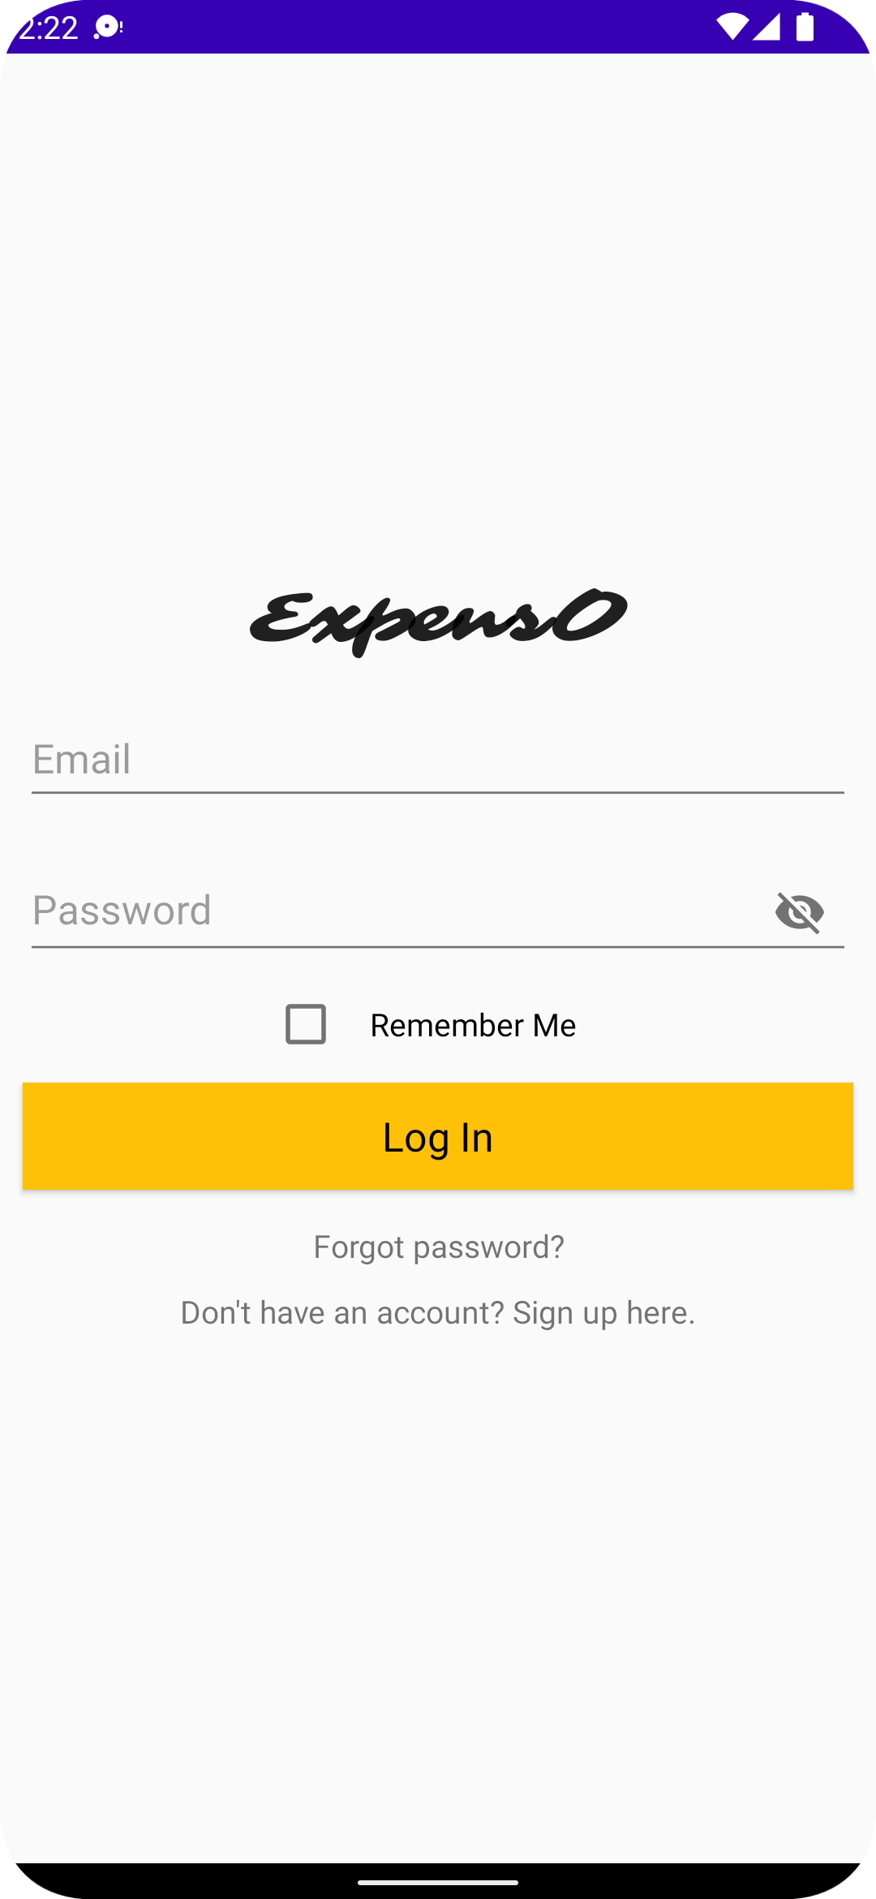

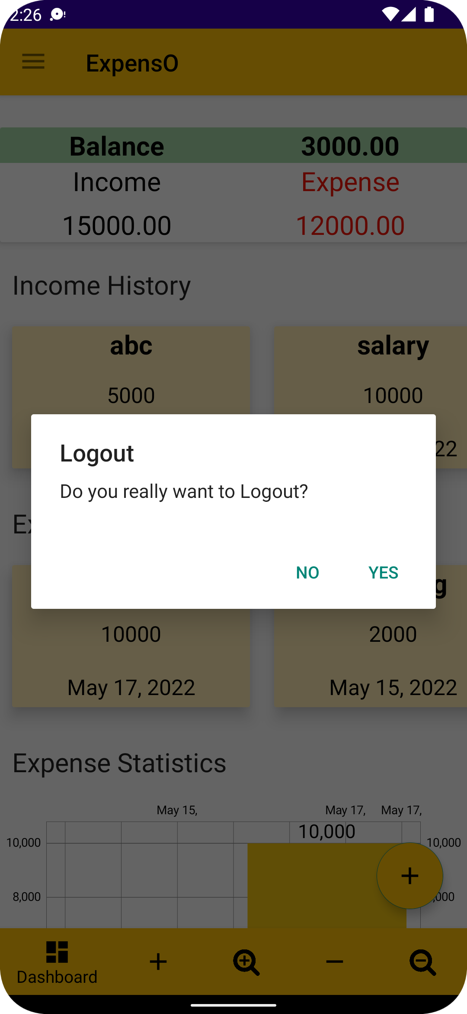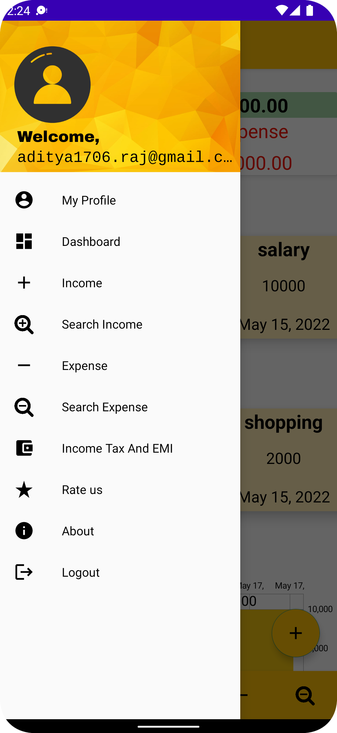

**MENU PAGE**

**LOGOUT PAGE**

**SIGNUP PAGE**

**LOGIN PAGE**

**PASSWORD RESET PAGE**

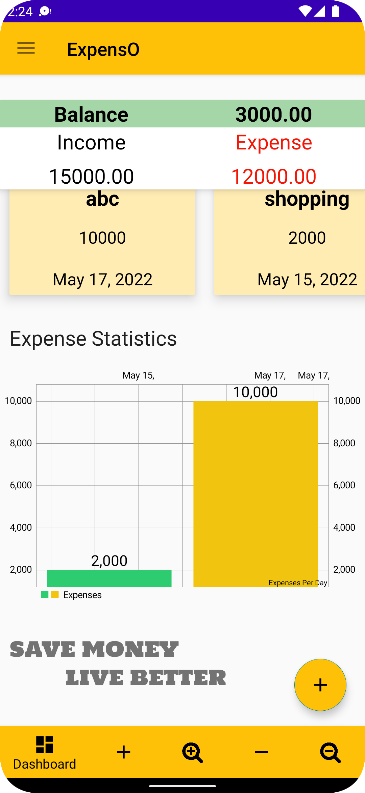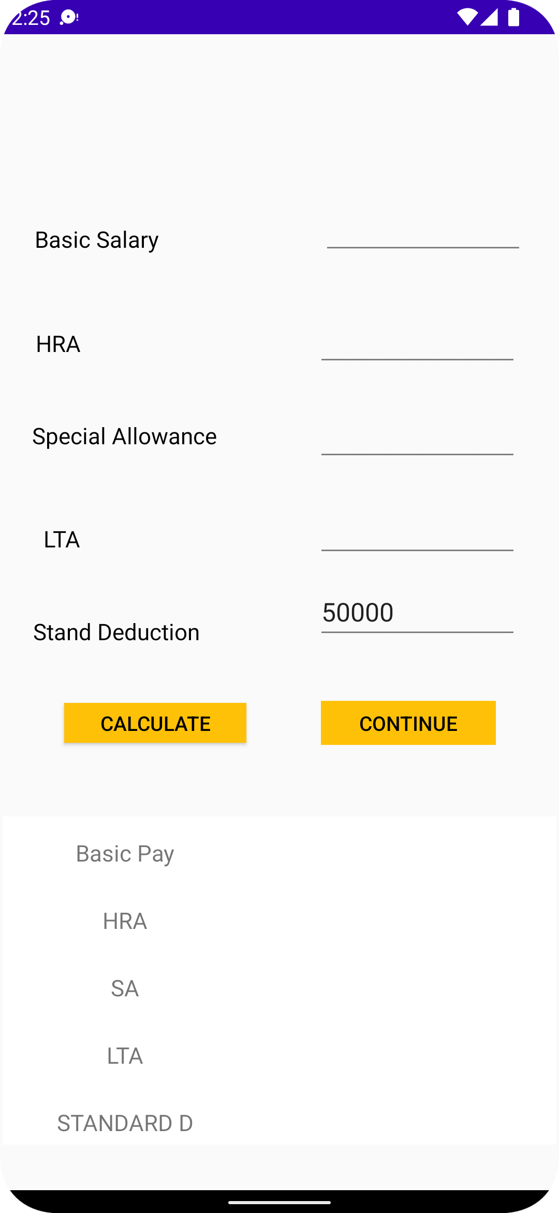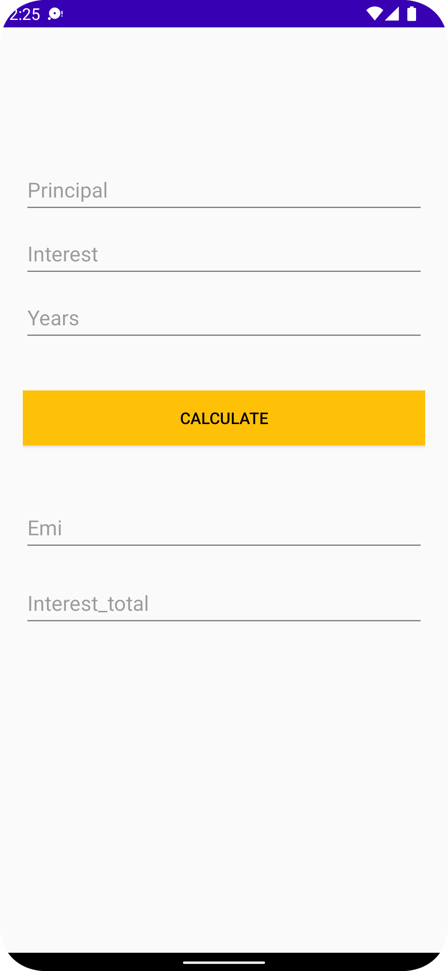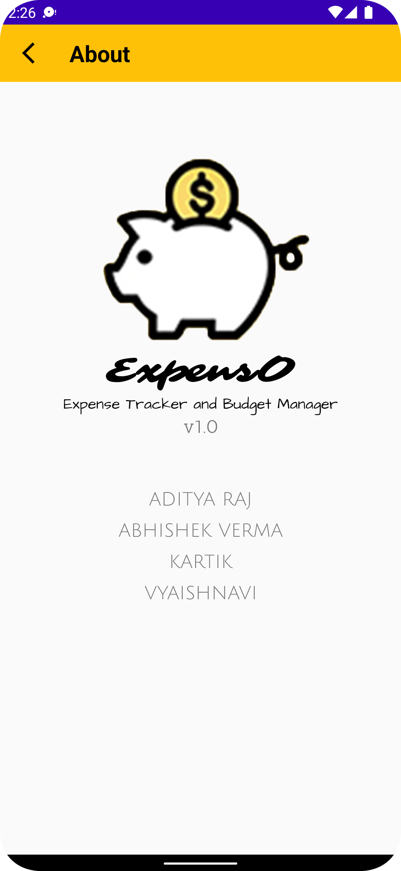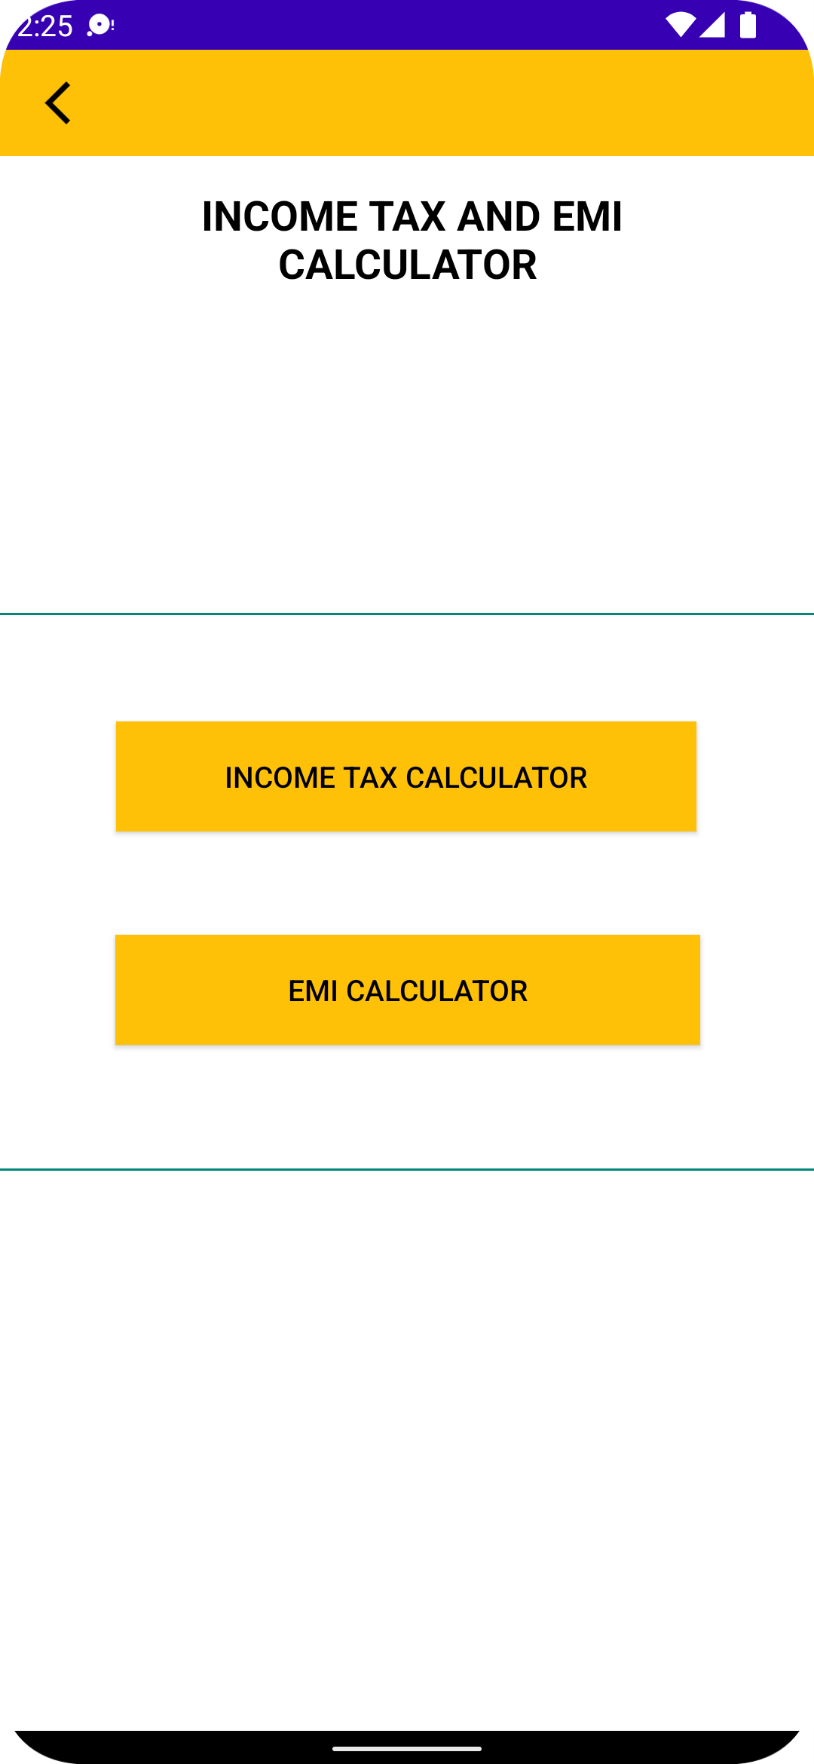

**TOOLS PAGE**

**ABOUT PAGE**

**INTEREST CALCULATOR**

**EMI CALCULATOR**

**DASHBOARD PAGE**

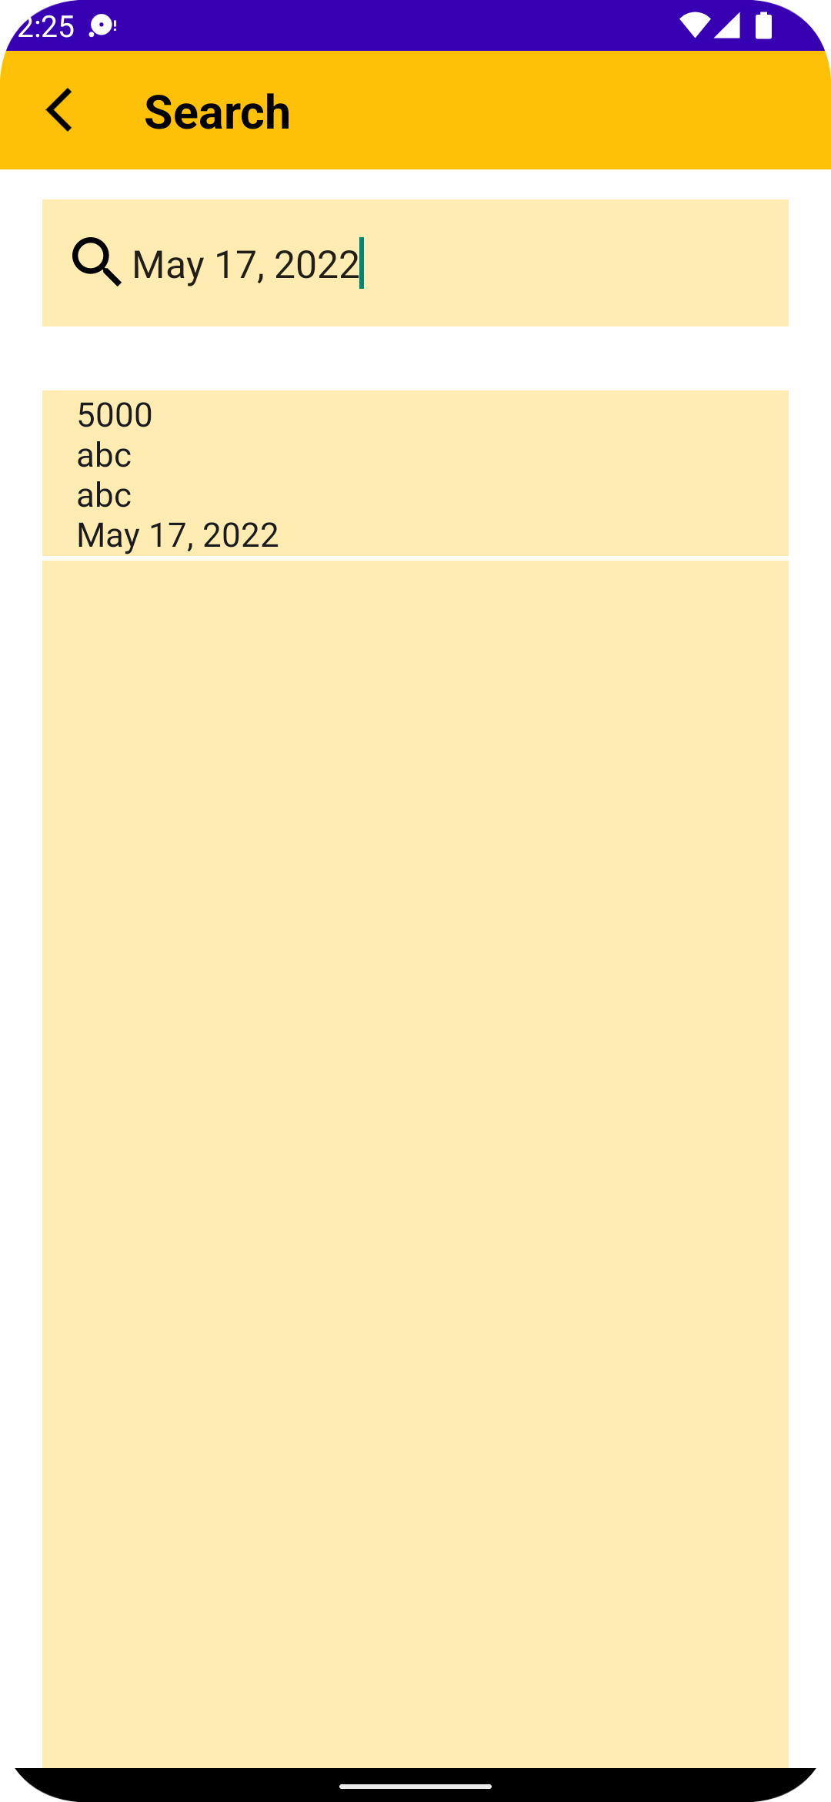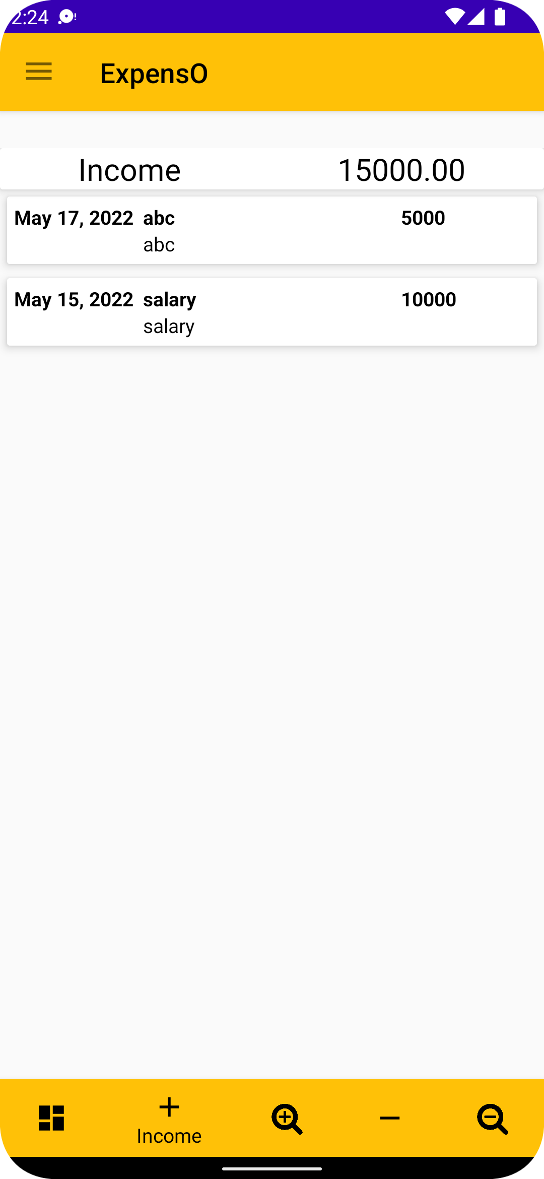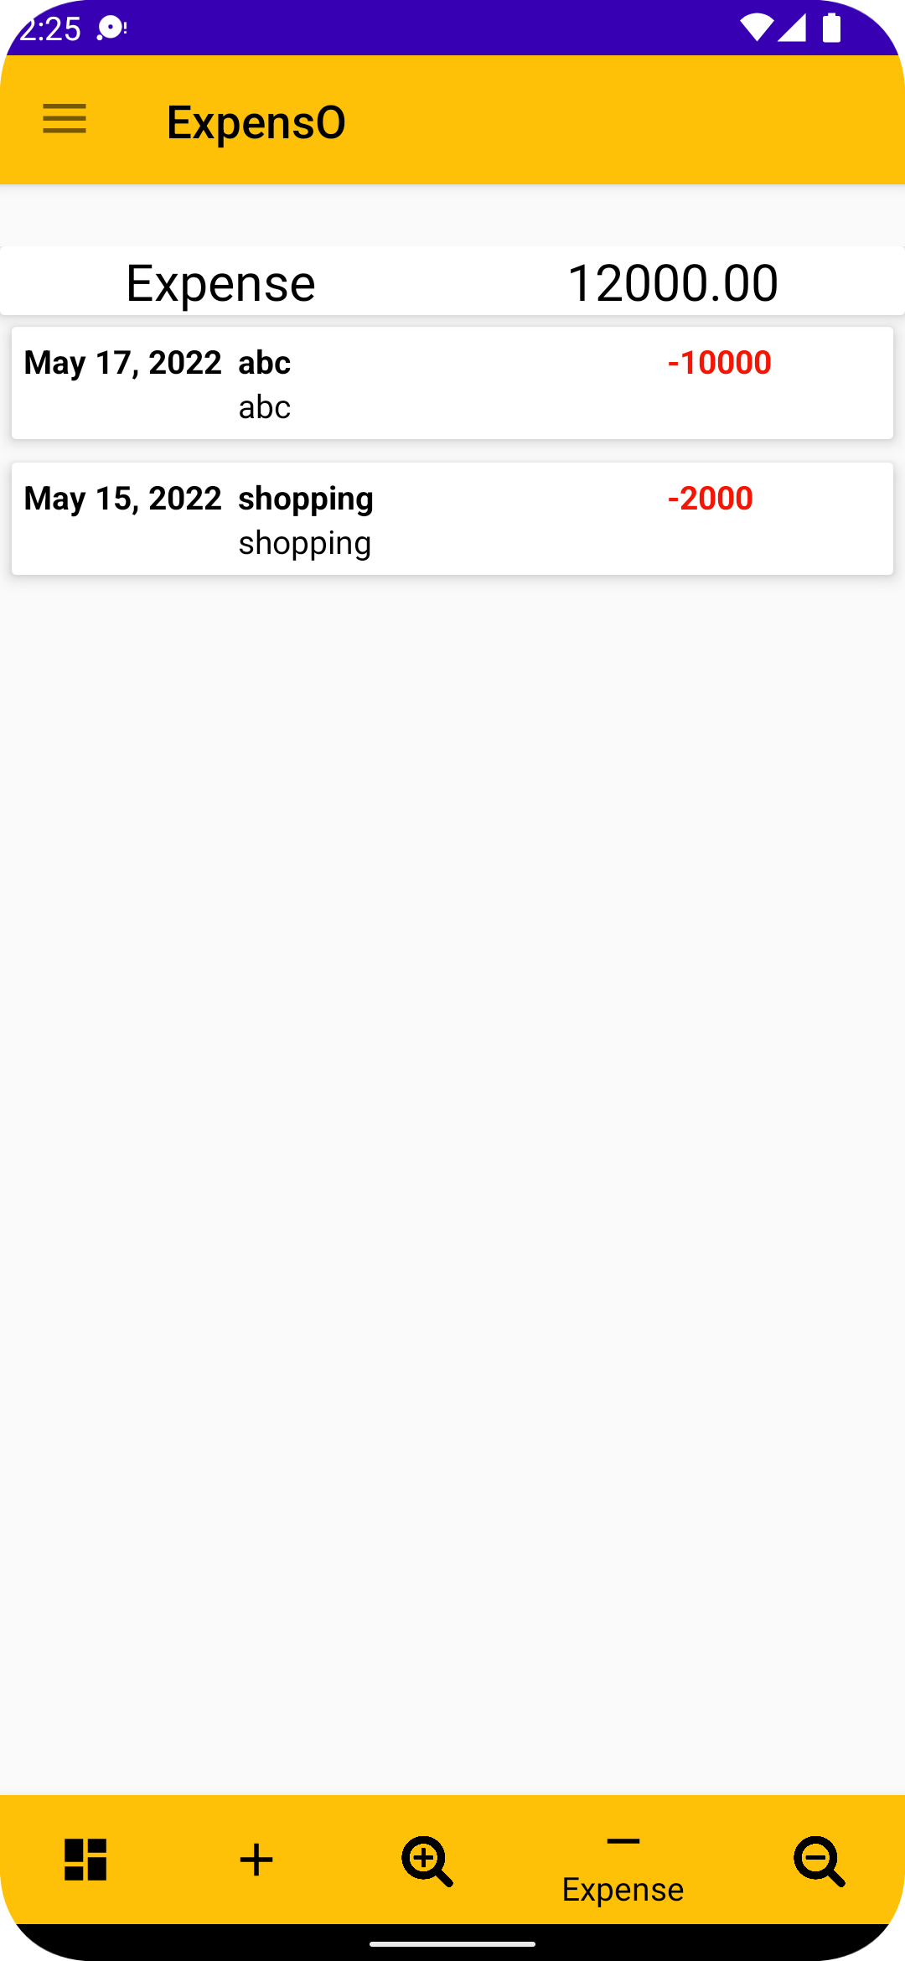

**SEARCH PAGE**

**INCOME HISTORY PAGE**

**EXPENSE HISTORY PAGE**

**Chapter 5: Code and Source File**

User Manual for using Application :

1. Open the App.
2. Click on “**Don’t have a account? Sign in here”.**
3. Verification will be sent to the email.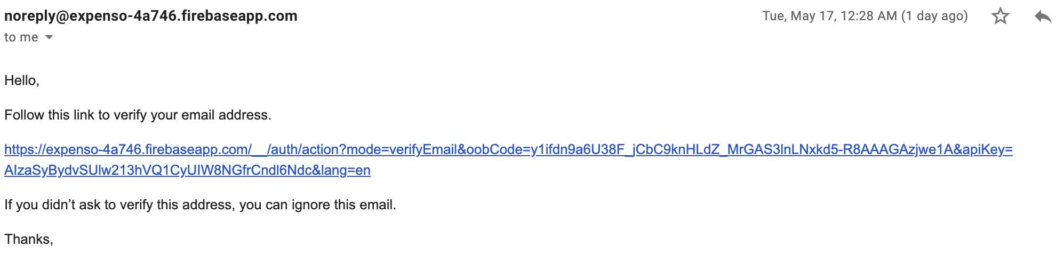
4. Verify the email and return the app and open the login page and login.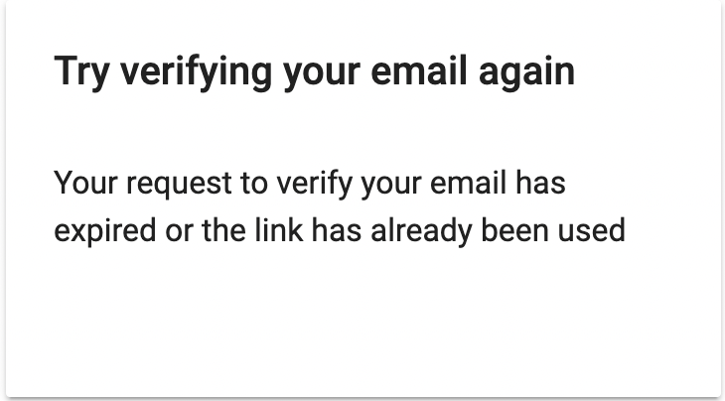
5. To add the income simply click on **‘ + ’** and to add the expenses click on **‘ - ’.**
6. To search the expense or income click on **“ search + ”** or **“ search - ”.**
7. To easily see the expense scroll down to the graph to get the bar chart.
8. To delete the account click on profiles and delete the account.
9. To change the password click on profiles and change the password using the old password.

**PROJECT SOURCE CODE AVALIABLE ON GITHUB :**

<https://github.com/iadiraj/expensO>

**Chapter 5: Conclusion and future work**

The entire premise for wanting an automated expense management software is to automate and streamline certain aspects of expense management. With one click approvals on submitted expenses, approvers can just approve or reject expenses without wasting time on validating individual spends. Some expense management software also provide the option of customizing approval hierarchies with multi-level approvers, where required.

**Scope and time:**

1. The present work is an android application titled ExpensO that was taken up as part of the student project. It aims at expense management among students who travel in groups and would like to have a tool to ease the process of managing their expenses. Based on existing apps and literature survey, hash-maps proves to be an efficient mapping technique in Android apps for handling large amount of data.
2. ExpensO uses hash-maps for the similar reasons and the results are quite satisfying. This app will save a lot of time that people manually waste on these calculations.
3. Hoping that this application does better in the future there are enhancement plans for the application.
4. Currently, the app is working for a single user to make the calculations and shares the results with its group members through emails. This could be enhanced by providing a link through which the other users could download the application and have the details of the events saved.
5. In future ,there could also be a direct connectivity between applications running on multiple devices for that event. Thus, notifications could be sent easily. Money transfers could be implemented by linking it to some e-wallet and make payments across accounts through mobile numbers or actual bank account numbers.

**Chapter 6: References**

[1] <https://developer.android.com/guide/topics/ui>

[2] <https://developer.android.com/guide/topics/search/search-dialog>

[3] <https://developer.android.com/training/basics/intents/sending>

[4] <https://firebase.google.com/docs/auth/android/start>

[5] <https://firebase.google.com/docs/auth/android/email-link-auth>

[6] <https://firebase.google.com/docs/auth/android/password-auth>

[7] <https://firebase.google.com/docs/database/android/read-and-write>

[8] <https://link.springer.com/chapter/10.1007/978-3-030-90119-6_21>

[9] <https://ieeexplore.ieee.org/abstract/document/8628070>  
[10] <https://link.springer.com/chapter/10.1007/978-3-030-90119-6_21>

[11] [https://www.researchgate.net/profile/Laura-Brad/publication/](https://www.researchgate.net/profile/Laura-Brad/publication/%2520260083245_QUANTIFYING_THE_ROMANIAN_BANKS'_PERFORMANCE_A%2520ND_THE_IMPACT_OF_AUDIT_INSPECTIONS_UPON_THEM_WHEN_IFRS_%2520REPORTING_STANDARDS_IS_USED/links/0a85e534000ec1caed000000/%2520QUANTIFYING-THE-ROMANIAN-BANKS-PERFORMANCE-AND-THE-%2520IMPACT-OF-AUDIT-INSPECTIONS-UPON-THEM-WHEN-IFRS-REPORTING-%2520STANDARDS-IS-USED.pdf%23page=107) 260083245_QUANTIFYING_THE_ROMANIAN_BANKS'_PERFORMANCE_A ND_THE_IMPACT_OF_AUDIT_INSPECTIONS_UPON_THEM_WHEN_IFRS_ REPORTING_STANDARDS_IS_USED/links/0a85e534000ec1caed000000/ QUANTIFYING-THE-ROMANIAN-BANKS-PERFORMANCE-AND-THE- IMPACT-OF-AUDIT-INSPECTIONS-UPON-THEM-WHEN-IFRS-REPORTING- STANDARDS-IS-USED.pdf#page=107

[12] <https://www.w3schools.com/kotlin/index.php>

[13] <https://www.w3schools.com/java/default.asp>

[14] <https://developer.android.com/courses>